# Question

Given two sorted integer arrays nums1 and nums2, merge nums2 into nums1 as one sorted array.

The number of elements initialized in nums1 and nums2 are m and n respectively. You may assume that nums1 has a size equal to m + n such that it has enough space to hold additional elements from nums2.

**Example 1:**

**Input:** nums1 = [1,2,3,0,0,0], m = 3, nums2 = [2,5,6], n = 3

**Output:** [1,2,2,3,5,6]

**Example 2:**

**Input:** nums1 = [1], m = 1, nums2 = [], n = 0

**Output:** [1]

**Constraints:**

* nums1.length == m + n
* nums2.length == n
* 0 <= m, n <= 200
* 1 <= m + n <= 200
* -109 <= nums1[i], nums2[i] <= 109

Hide Hint #1

You can easily solve this problem if you simply think about two elements at a time rather than two arrays. We know that each of the individual arrays is sorted. What we don't know is how they will intertwine. Can we take a local decision and arrive at an optimal solution?

Hide Hint #2

If you simply consider one element each at a time from the two arrays and make a decision and proceed accordingly, you will arrive at the optimal solution.

# Solution

#### **Approach 1 : Merge and sort**

**Intuition**

A naive approach would be to simply write the values from nums2 into the end of nums1, and then sort nums1. Remember that we do not need to return a value, as we should modify nums1 in-place. While straightforward to code, this approach has a high time complexity as we're not taking advantage of the existing sorting.

**Implementation**

|  |
| --- |
| class Solution {  public void merge(int[] nums1, int m, int[] nums2, int n) {  for (int i = 0; i < n; i++) {  nums1[i + m] = nums2[i];  }  Arrays.sort(nums1);  }  } |

* Time complexity : \mathcal{O}((n + m)\log(n + m))O((*n*+*m*)log(*n*+*m*)).

The cost of sorting a list of length x*x* using a built-in sorting algorithm is \mathcal{O}(x \log x)O(*x*log*x*). Because in this case we're sorting a list of length m + n*m*+*n*, we get a total time complexity of \mathcal{O}((n + m) \log (n + m))O((*n*+*m*)log(*n*+*m*)).

* Space complexity : \mathcal{O}(n)O(*n*), but it can vary.

Most programming languages have a built-in sorting algorithm that uses \mathcal{O}(n)O(*n*) space.

#### **Approach 2 : Three Pointers (Start From the Beginning)**

**Intuition**

Because each array is already sorted, we can achieve an \mathcal{O}(n + m)O(*n*+*m*) time complexity with the help of the two-pointer technique.

**Algorithm**

The simplest implementation would be to make a copy of the values in nums1, called nums1Copy, and then use two **read** pointers and one **write** pointer to read values from nums1Copy and nums2 and write them into nums1.

* Initialize nums1Copy to be a new array containing the first m values of nums1.
* Initialize read pointer p1 to the beginning of nums1Copy.
* Initialize read pointer p2 to the beginning of nums2.
* Initialize write pointer p to the beginning of nums1.
* While p is still within nums1:
  + If nums1Copy[p1] exists and is less than or equal to nums2[p2]:
    - Write nums1Copy[p1] into nums1[p], and increment p1 by 1.
  + Else
    - Write nums2[p2] into nums1[p], and increment p2 by 1.
  + Increment p by 1.

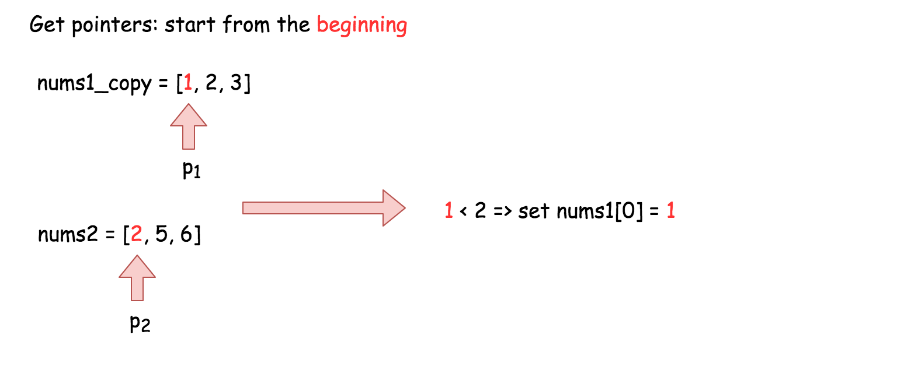

**Implementation**

|  |
| --- |
| class Solution {  public void merge(int[] nums1, int m, int[] nums2, int n) {  // Make a copy of the first m elements of nums1.  int[] nums1Copy = new int[m];  for (int i = 0; i < m; i++) {  nums1Copy[i] = nums1[i];  }  // Read pointers for nums1Copy and nums2 respectively.  int p1 = 0;  int p2 = 0;  // Compare elements from nums1Copy and nums2 and write the smallest to nums1.  for (int p = 0; p < m + n; p++) {  // We also need to ensure that p1 and p2 aren't over the boundaries  // of their respective arrays.  if (p2 >= n || (p1 < m && nums1Copy[p1] < nums2[p2])) {  nums1[p] = nums1Copy[p1++];  } else {  nums1[p] = nums2[p2++];  }  }  }  } |

**Complexity Analysis**

* Time complexity : \mathcal{O}(n + m)O(*n*+*m*).

We are performing n + 2 \cdot m*n*+2⋅*m* reads and n + 2 \cdot m*n*+2⋅*m* writes. Because constants are ignored in Big O notation, this gives us a time complexity of \mathcal{O}(n + m)O(*n*+*m*).

* Space complexity : \mathcal{O}(m)O(*m*).

We are allocating an additional array of length m*m*.

#### **Approach 3 : Three Pointers (Start From the End)**

**Intuition**

**Interview Tip**: This is a medium-level solution to an easy-level problem. Many of LeetCode's easy-level problems have more difficult solutions, and good candidates are expected to find them.

Approach 2 already demonstrates the best possible time complexity, \mathcal{O}(n + m)O(*n*+*m*), but still uses additional space. This is because the elements of array nums1 have to be stored somwhere so that they aren't overwritten.

So, what if instead we start to overwrite nums1 from the end, where there is no information yet?

The algorithm is similar to before, except this time we set p1 to point at index m - 1 of nums1, p2 to point at index n - 1 of nums2, and p to point at index m + n - 1 of nums1. This way, it is guaranteed that once we start overwriting the first m values in nums1, we will have already written each into its new position. In this way, we can eliminate the additional space.

**Interview Tip**: Whenever you're trying to solve an array problem in-place, always consider the possibility of iterating backwards instead of forwards through the array. It can completely change the problem, and make it a lot easier.

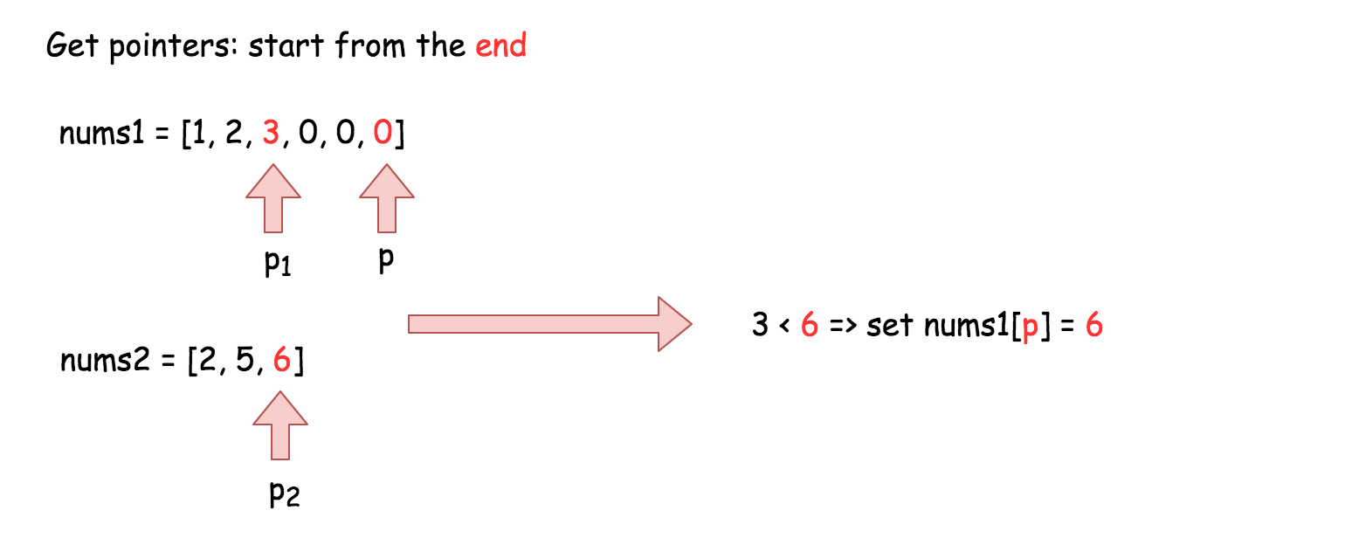

**Implementation**

|  |
| --- |
| class Solution {  public void merge(int[] nums1, int m, int[] nums2, int n) {  // Set p1 and p2 to point to the end of their respective arrays.  int p1 = m - 1;  int p2 = n - 1;    // And move p backwards through the array, each time writing  // the smallest value pointed at by p1 or p2.  for (int p = m + n - 1; p >= 0; p--) {  if (p2 < 0) {  break;  }  if (p1 >= 0 && nums1[p1] > nums2[p2]) {  nums1[p] = nums1[p1--];  } else {  nums1[p] = nums2[p2--];  }  }  }  } |

**Complexity Analysis**

* Time complexity : \mathcal{O}(n + m)O(*n*+*m*).

Same as Approach 2.

* Space complexity : \mathcal{O}(1)O(1).

Unlike Approach 2, we're not using an extra array.

**Proof (optional)**

You might be a bit sceptical of this claim. Does it really work in every case? Is it safe to be making such a bold claim?

This way, it is guaranteed that once we start overwriting the first m values in nums1, we will have already written each into its new position. In this way, we can eliminate the additional space.

Great question! So, why does this work? To prove it, we need to ensure that p never overwrites a value in nums1 that p1 hasn't yet read from nums1.

**Words of Advice**: Terrified of proofs? Many software engineers are. Good proofs are simply a series of logical assertions, each building on the next. In this way, we can go from "obvious" statements, all the way to the one we want to prove. I recommend reading each statement one-by-one, ensuring that you understand each before moving onto the next.

1. We know that upon initialization, p is n steps ahead of p1 (in other words, p1 + n = p).
2. We also know that during each of the p iterations this algorithm performs, p is always decremented by 1, and either p1 or p2 is decremented by 1.
3. We can deduce that when p1 decremented, the gap between p and p1 stays the same, so there can't be an "overtake" in that case.
4. We can also deduce that when p2 is decremented though, the gap between p and p1 shrinks by 1 as p moves, but not p1.
5. And from that, we can deduce that the maximum number of times that p2 can be decremented is n. In other words, the gap between p and p1 can shrink by 1, at most n times.
6. In conclusion, it's impossible for an overtake to occur, as they started n apart. And when p = p1, the gap has to have shrunk n times. This means that all of nums2 have been merged in, and so there is nothing more to do.